**Answer Sheet - SQL**

Name : Priyanka Arora

Phone No. : 9149113191

Email : [arora09011987@gmail.com](mailto:arora09011987@gmail.com)

**Question 1**

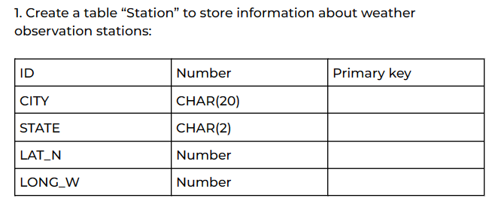

Insert Image-

*Create table Station*

*(*

*ID number Primary Key,*

*CITY Char(20),*

*STATE char(20),*

*LAT_N Number,*

*LONG_W Number*

*);*

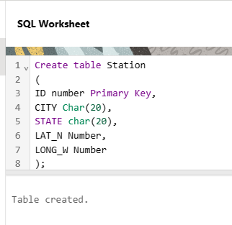

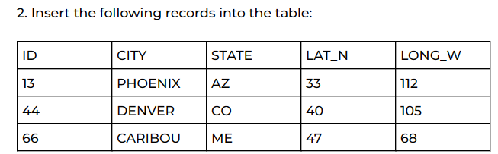

*INSERT INTO STATION VALUES (13,'PHONEIX', 'AZ', 33,112);*

*INSERT INTO STATION VALUES (44,'DENVER', 'CO', 40,105);*

*INSERT INTO STATION VALUES (66,'CARIBOU', 'ME',47,68);*

Insert Image –

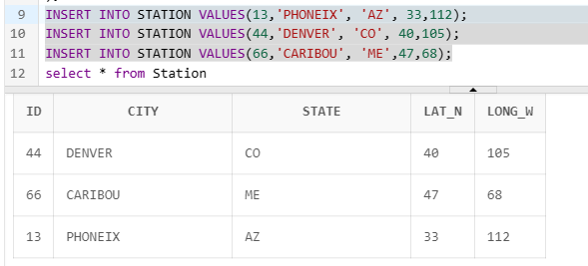

3. Execute a query to look at table STATION in undefined order

*Select * from Station*

Insert Image –

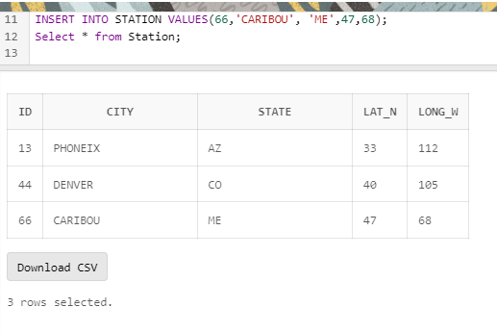

**Q.4. Execute a query to select Northern stations (Northern latitude >39.7).**

*Select * from Station*

*where LAT_N >39.7;*

Insert Image –

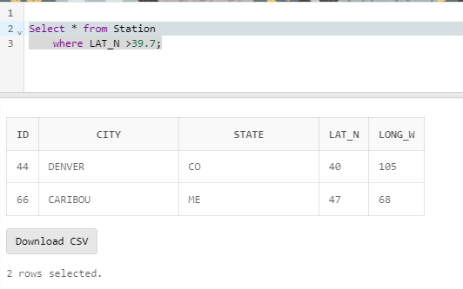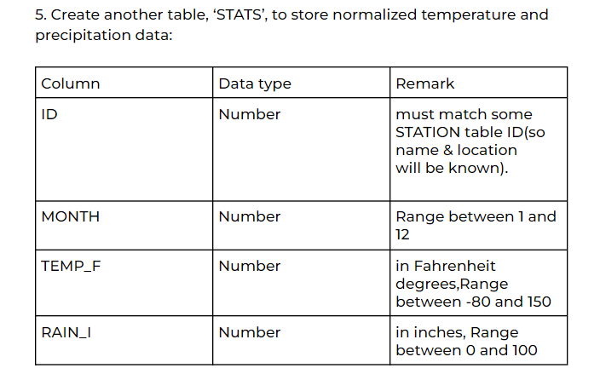

*Create table STATS*

*(*

*ID number references STATION(ID),*

*MONTH number,*

*TEMP_F number,*

*RAIN_I number*

*);*

Insert Image –

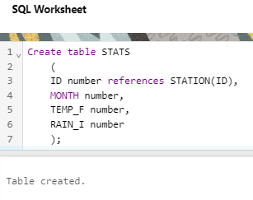

**6.Populate the table STATS with some statistics for January and July:**

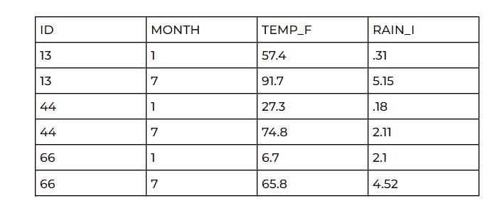

*insert into STATS values (13,1,57.4,0.31);*

*insert into STATS values (13,7,91.7,5.15);*

*insert into STATS values (44,1,27.3,0.18);*

*insert into STATS values (44,7,74.8,2.11);*

*insert into STATS values (66,1,6.7,2.1);*

*insert into STATS values (66,7,65.8,4.52);*

*select * from stats;*

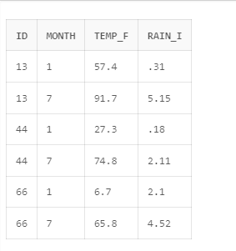



*Select stats.id, stats.temp_f, station.city*

*from stats*

*join station*

*on station.ID = stats.id;*

Insert Image –

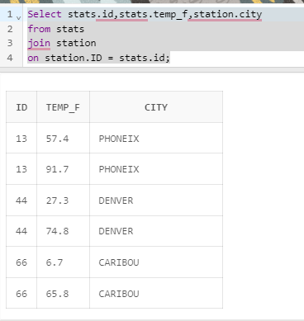

**8**.**Execute a query to look at the table STATS, ordered by month and greatest rainfall, with columns rearranged. It should also show the corresponding cities.**

*Select s.month, s.RAIN_I, st.city*

*From STATS s*

*join STATION st*

*ON s.ID = st.ID*

*Order by Month, RAIN_I Desc;*

Insert Image –

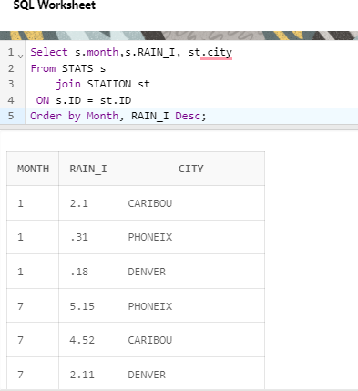

**9.Execute a query to look at temperatures for July from table STATS lowest temperatures first ,picking up city name and latitude.**

*Select s.month, s.RAIN_I, st.city*

*From STATS s*

*join STATION st*

*ON s.ID = st.ID*

*Order by Month, RAIN_I Desc;*

|  |
| --- |
| **10.Execute a query to show MAX and MIN temperatures as well as the average rainfall for each city**  *select st.city, min(s.TEMP_F)as MIN_Temperature,max(s.TEMP_F) as MAX_Temperature, avg(s.RAIN_I) as AVG_Rain*  *From stats s*  *join STATION st*  *on s.ID =st.Id*  *Group by st.city;* |
|  |
| **11. Execute a query to display each city’smonthly temperature in Celcius and rainfall in Centimeters**  *select st.city, month,Round(((temp_F-32)*5/9),2) as temp_celsius,(Rain_I-2.54) as rainfall_in_Centimeter*  *From stats s*  *join STATION st*  *on s.ID =st.Id* |
|  |
| |  | | --- | |  | |
|  |

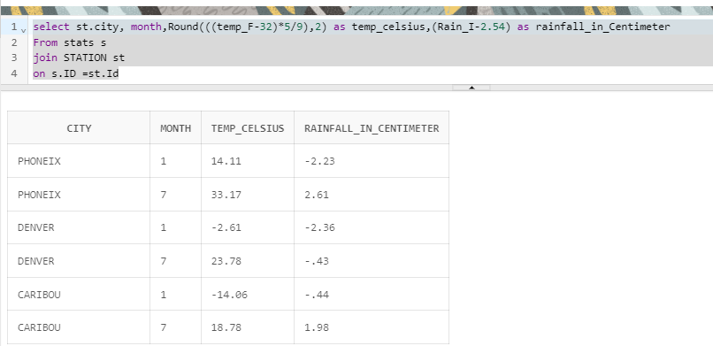**12.Update All Rows of table STATS to compensate for faulty rain gauges known to read 0.01 inches low.**

|  |
| --- |
| *UPDATE STATS SET RAIN_I = RAIN_I + 0.01;* |
| *select * from stats* |

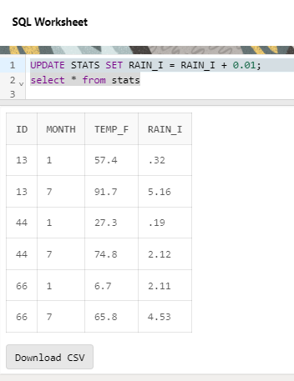

**13.UpdateDenver'sJulytemperaturereadingas74.9**

*Update Stats set TEMP_F= 74.9*

*Where Month = 7 and Id= 44*

*select * from stats*

